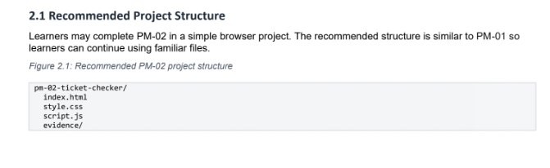

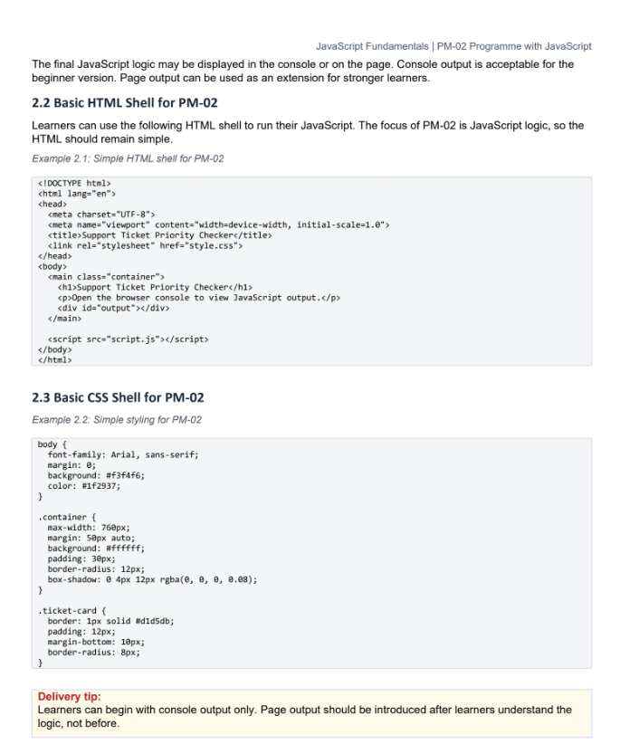

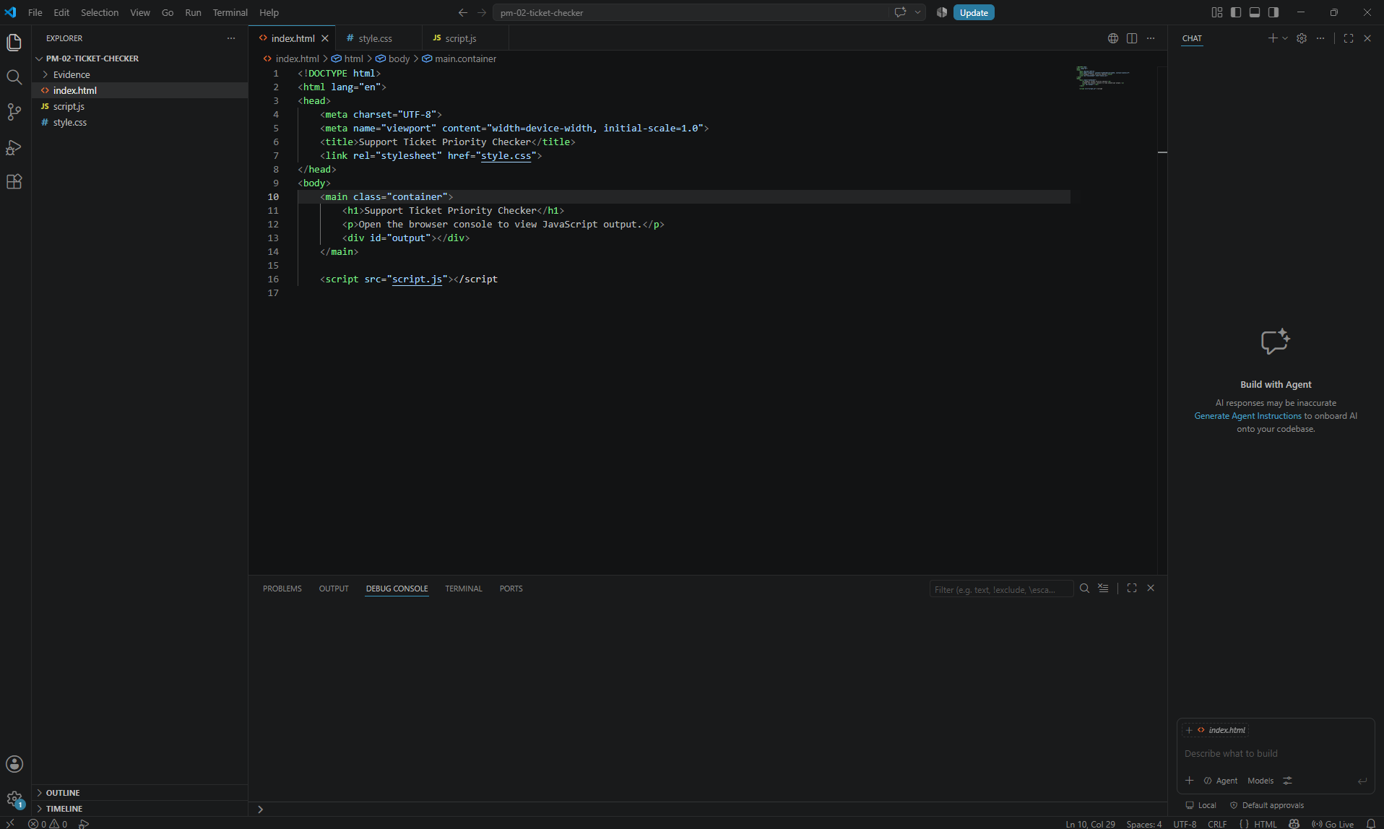

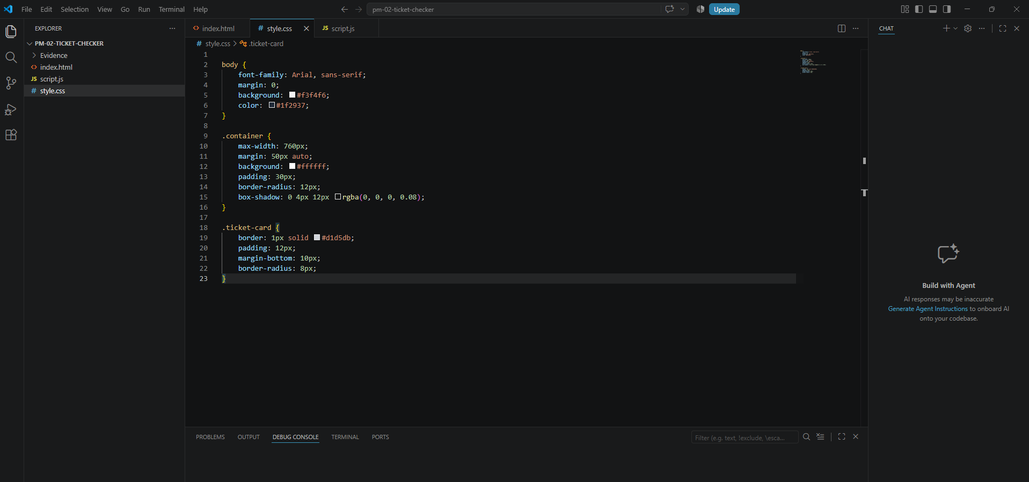

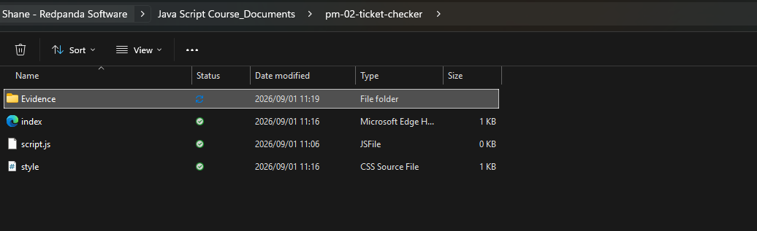

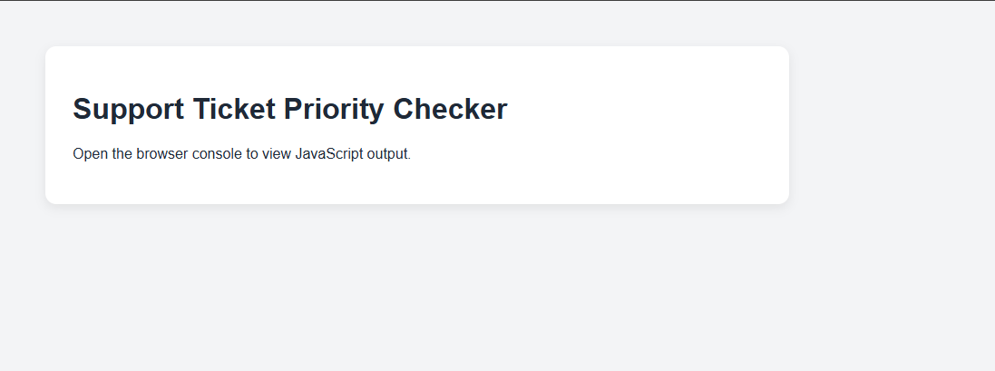

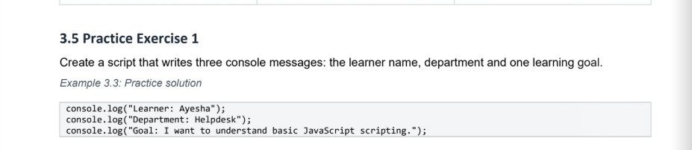

javascript
console.log("Learner: Shane");
console.log("Department: Orion");
console.log("I want to be equipped on Java Script.");

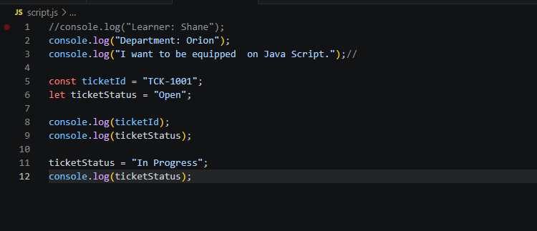

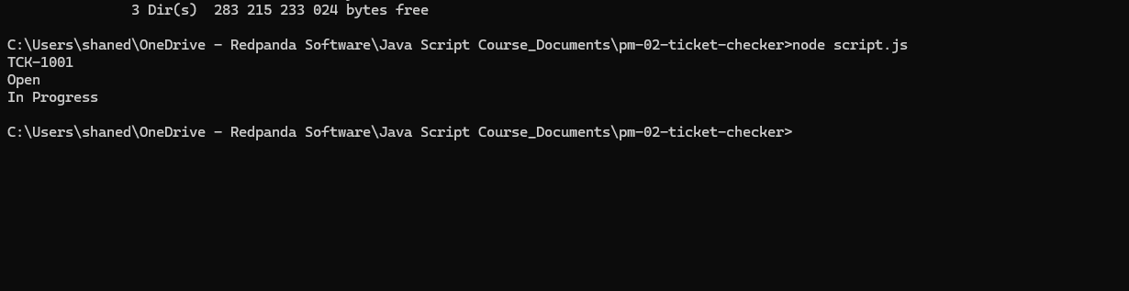

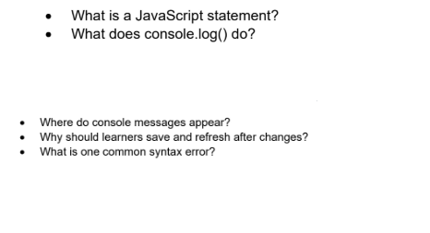

1. What is a JavaScript statement?
An instruction that tells the browser what action to perform.
- Example: let x = 5;
2. What does console.log() do?
It prints text or data into the browser's developer console for inspection.
- Example: console.log("Hello World");
3. Where do console messages appear?
Inside the browser's developer tools under the Console tab.
- Example: Access it by pressing F12 or right-clicking a page and selecting Inspect.
4. Why should learners save and refresh after changes?
Saving applies updates to the source files. Refreshing forces the browser to load and run that newly updated code.
- Example: If you change a message from "Open" to "Closed" in your editor, you must save and refresh to see the change on your live page.
5. What is one common syntax error?
A missing punctuation mark, like a closing bracket or parenthesis, which breaks code execution.
- Example: console.log("Hello"; (Missing the closing parenthesis )).

Let and const
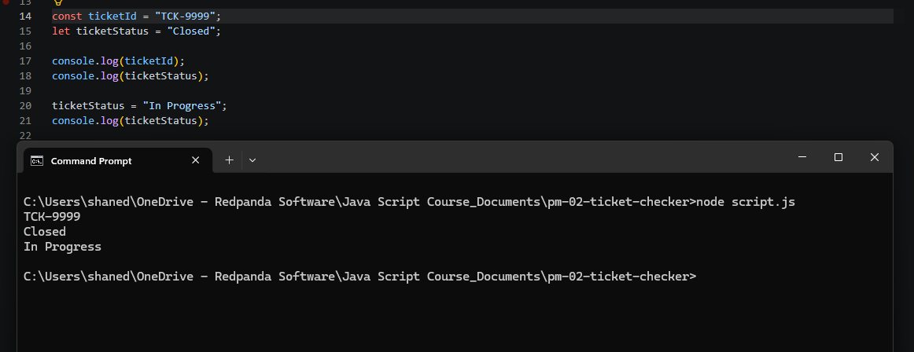

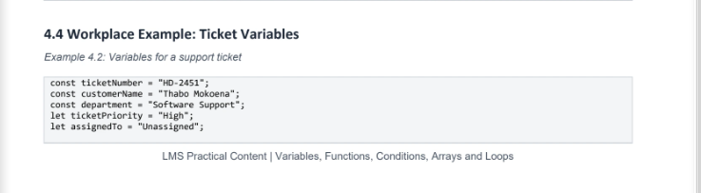

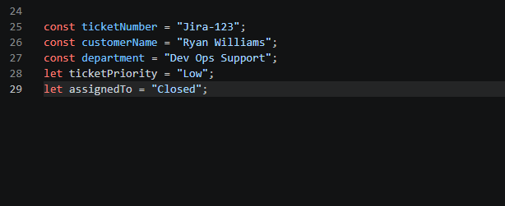

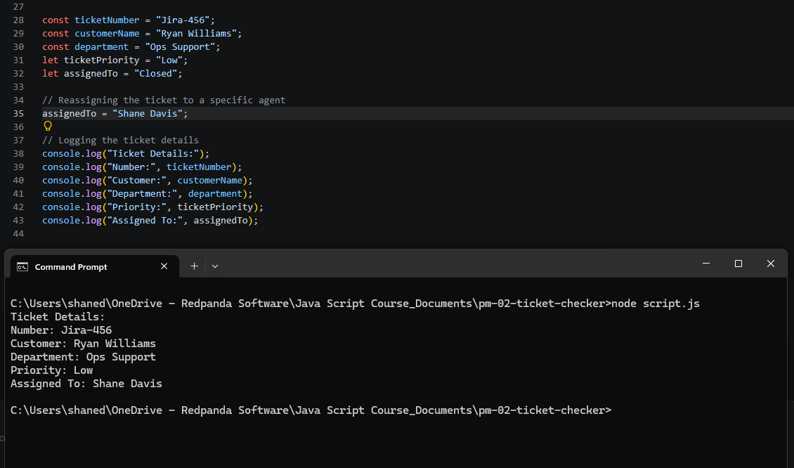

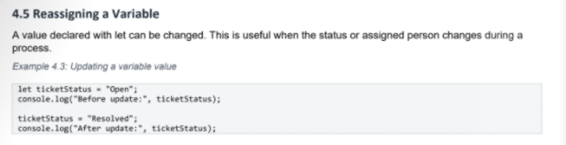

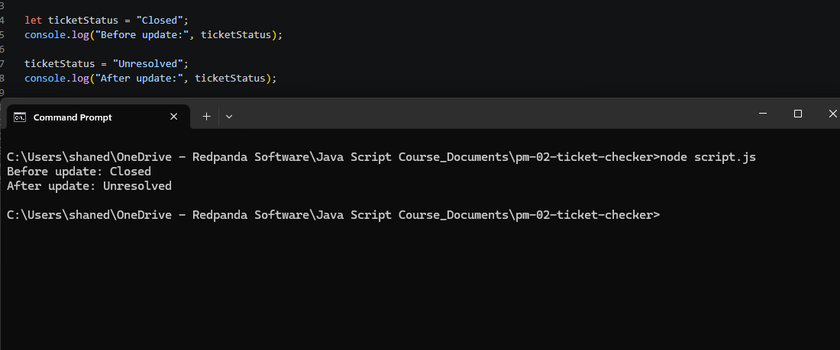

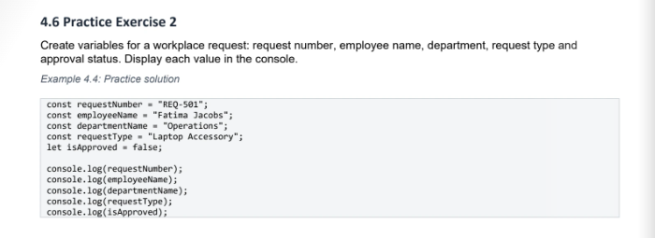

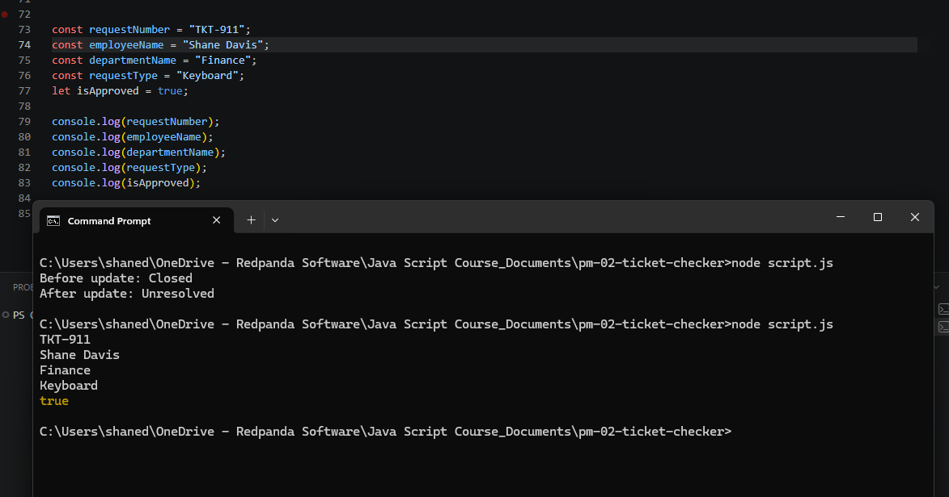

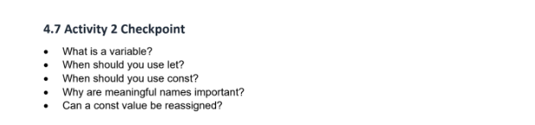

1. What is a variable?
A variable is a named container used to store data or information that your program can use and change later.
2. When should you use let?
Use let when you know the value of the variable will need to change or be reassigned later in your code.
3. When should you use const?
Use const by default for any variable whose value should stay the same and never be completely reassigned.
4. Why are meaningful names important?
Meaningful names make code easy to read, understand, and maintain for both you and other developers.
5. Can a const value be reassigned?
No. Attempting to reassign a const variable will cause a runtime error in JavaScript.

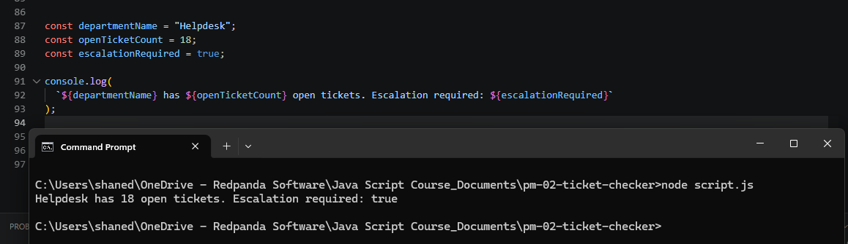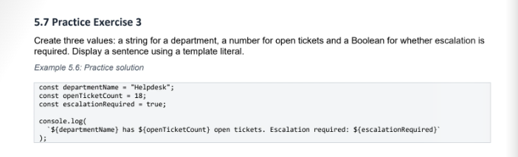

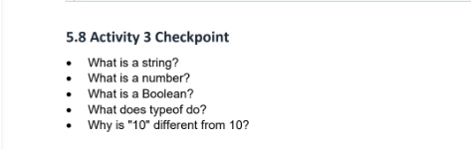

1. What is a string?
- Text data wrapped in quotes.
- Used for names or addresses.
- Example: "Helpdesk".
2. What is a number?
- Raw numerical data.
- Used for math calculations.
- Example: 18.
3. What is a Boolean?
- A simple true/false switch.
- Used for yes/no decisions.
- Example: true.
4. What does typeof do?
- Checks a variable's data type.
- Returns "string", "number", or "boolean".
- Example: typeof 10 outputs "number".
5. Why is "10" different from 10?
- "10" is text characters.
- 10 is an actual math value.
- You cannot add text values mathematically.

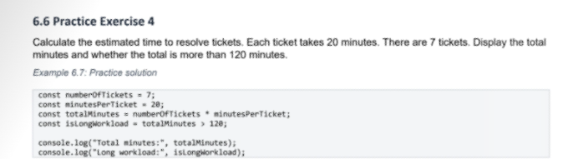

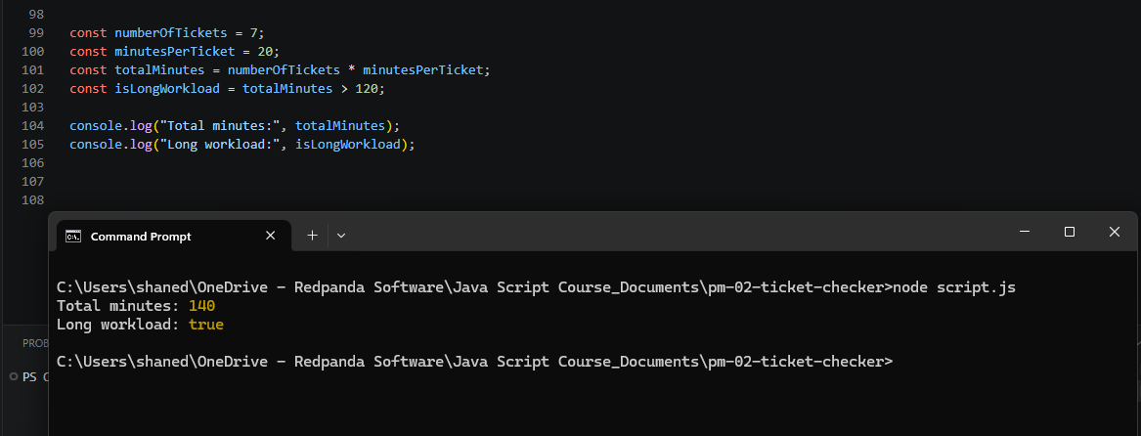

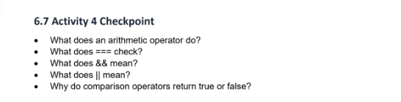

1. What does an arithmetic operator do?
- Performs standard math calculations on numbers.
- Examples include + (add), - (subtract), * (multiply), and / (divide).
2. What does === check?
- Checks if two values are exactly equal.
- It verifies both the value and the data type match perfectly.
- Example: 5 === 5 is true, but 5 === "5" is false.
3. What does && mean?
- The logical AND operator.
- It requires all conditions to be true at the same time.
- Example: You can log in if you have the correct email AND the correct password.
4. What does || mean?
- The logical OR operator.
- It requires only one of the conditions to be true.
- Example: You can enter if you have a VIP pass OR if you pay at the door.
5. Why do comparison operators return true or false?
- Because they ask a simple yes/no question.
- Code needs a decisive Boolean answer (true or false) to make choices.
- Example: Checking if tickets > 10 evaluates directly to a single true/false statement.

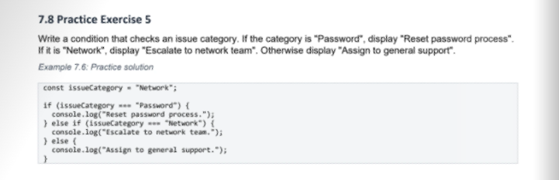

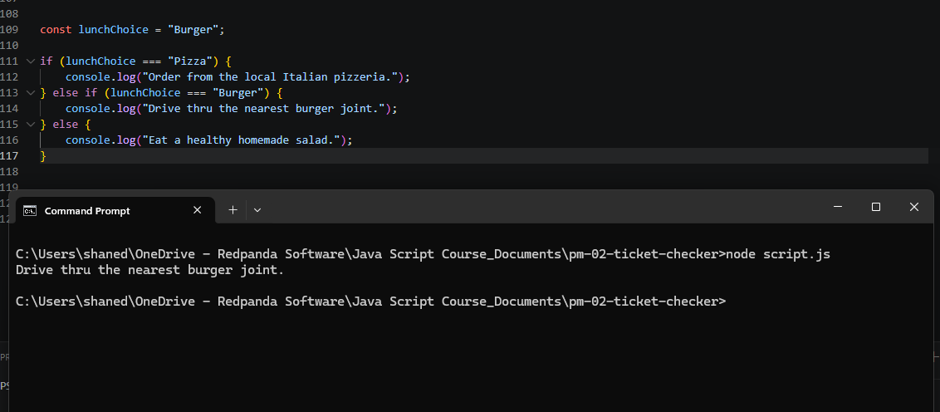

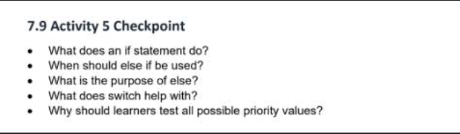

1. What does an if statement do?
- It checks a specific condition.
- It runs code only if that condition is true.
- Example: If it rains, open an umbrella.
2. When should else if be used?
- When the first condition is false.
- It checks a brand new alternative condition instead.
- Example: If it is not raining, check if it is snowing.
3. What is the purpose of else?
- It serves as a final backup plan.
- It runs if all previous conditions are false.
- Example: If it is not raining or snowing, just walk normally.
4. What does switch help with?
- It tests one variable against many fixed values.
- It cleans up long, messy if-else blocks.
- Example: Checking if a user status is "Admin", "Editor", or "Guest".
5. Why should learners test all possible priority values?
- To catch hidden bugs early.
- To guarantee every branch of code works perfectly.
- To make sure no condition causes a crash.

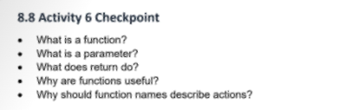

- What is a function? A reusable recipe or machine that performs a specific job when called.
- What is a parameter? The input slot or customization choice you pass into the machine (like choosing "Cappuccino").
- What does return do? It hands you the final, finished result so you can save or use it elsewhere.
- Why are functions useful? They stop you from writing the exact same code repeatedly.
- Why use action names? Using verbs like prepareCoffee makes your code read like plain instructions, making it easy for anyone to understand.

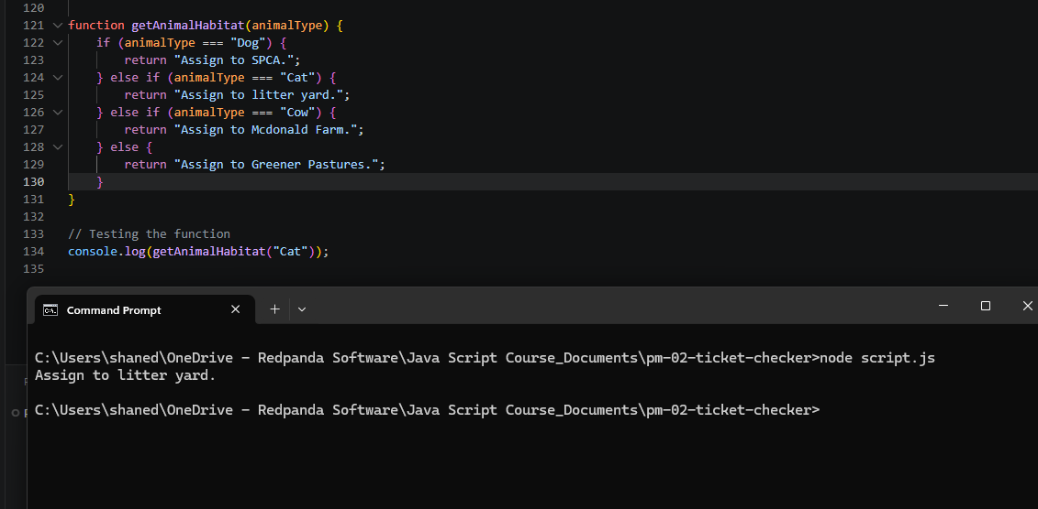

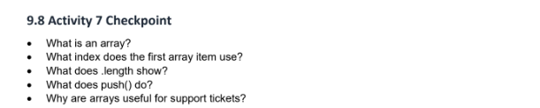

1. What is an array?
- A single variable that holds an ordered list of multiple items.
- It groups related data together in one place.
- Example: ["Apple", "Banana", "Orange"].
2. What index does the first array item use?
- Index 0.
- In programming, computers always start counting positions from zero, not one.
3. What does .length show?
- The total number of items currently inside the array.
- Example: An array with 3 items has a .length of 3.
4. What does push() do?
- Adds a new item to the very end of your existing array list.
- It automatically increases the .length of the array by 1.
5. Why are arrays useful for support tickets?
- They avoid creating individual variables like ticket1, ticket2, etc.
- They let you store hundreds of incoming customer issues inside a single list.
- They make it easy to automatically loop through and process tickets in order.

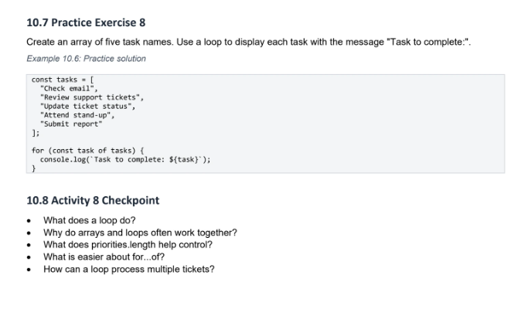

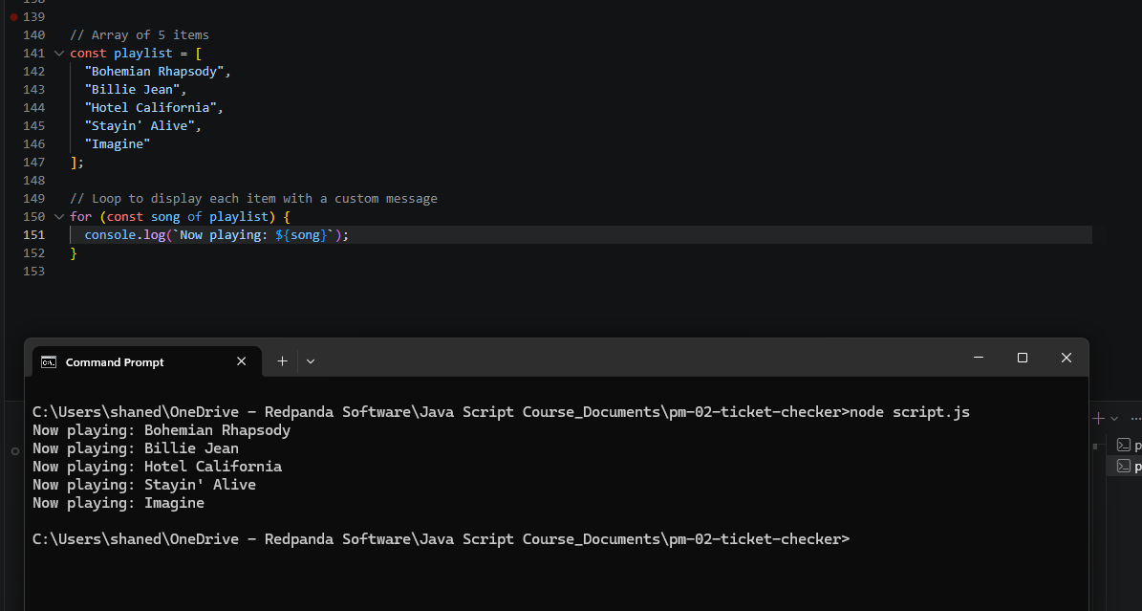

- What does a loop do? It repeats a block of code automatically so you don't have to type it manually.
- Why do arrays and loops work together? Arrays store lists of data, and loops step through those lists item by item.
- What does .length help control? It tells a standard loop exactly when to stop so it doesn't try to read items that aren't there.
- What is easier about for...of? It completely hides the index numbers ([i]), making your code much cleaner and easier to read.

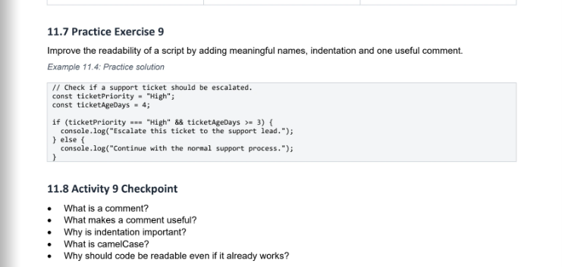

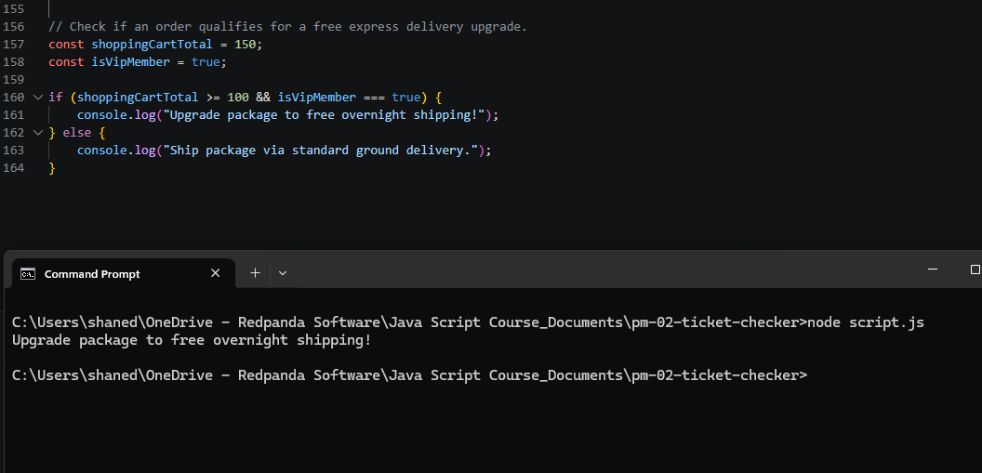

- What is a comment? Text started with // that the computer completely ignores. It is just for humans to read.
- What makes a comment useful? It explains why the code exists, rather than just repeating what the code physically says.
- Why is indentation important? It visually groups code blocks together between {} curly brackets. This makes structure obvious at a single glance.
- What is camelCase? A variable naming style where the first word is lowercase and every following word starts with a CapitalLetter (like shoppingCartTotal).
- Why should code be readable even if it works? Because you, your teammates, or your future self will need to update or fix this code months from now without getting a headache.

